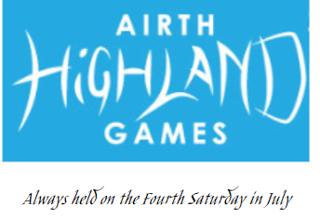

Andrew Paterson Memorial Solo Piping Competition
Sponsored by Paterson Garden Buildings & Decking Contractors

All competitors entering must report to Games Official in Treasurer’s office by 11am.
Competition draw is at 11.30am. Competition commences 12.30pm prompt.

Event | 1st | 2nd | 3rd | 4th
Adult Piobaireachd | £100 | £70 | £40 | £20
Adult March Strathspey Reel | £80 | £50 | £30 | £20
Adult Hornpipe and Jig | £80 | £50 | £30 | £20
16 to 18 years March Strathspey Reel | £50 | £30 | £20 | £10
15 years and under Slow Air | £30 | £20 | £10
15 years and under March | £30 | £20 | £10

Entry Fees:
Adults £5 per event
16 to18 years £3 per event
15 years and under £2 per event

Please enter by replying to secretary.airthgames@gmail.com confirming your name, age, events entered and confirmation that payment has been made.

Payment made via bank transfer to Airth Highland Gathering,
Account 00617991 Sort code 832032
Please include your name & event(s) entered
(please note that entries can also be taken on the day)

Many thanks
Event Organiser
EMMA GILLANDERS
Tel: 07429696438
secretary.airthgames@gmail.com
www.airthhighlandgames.com

