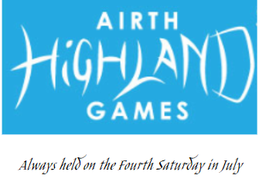
Heavy Events Entry Form
Competition commences at 12.30pm prompt. Held under R.S.H.G.A & Airth Highland Games rules

 | Event | 1st | 2nd | 3rd | 4th | 5th | 6th
1 | 16lbs hammer | £60 | £40 | £20 | £15 | £10 | -
2 | 22lbs hammer | £60 | £40 | £20 | £15 | £10 | -
3 | 16lbs ball | £60 | £40 | £20 | £15 | £10 | -
4 | 22lbs ball | £60 | £40 | £20 | £15 | £10 | -
5 | 56lbs weight over bar | £60 | £40 | £20 | £15 | £10 | -
6 | Caber | £60 | £40 | £20 | £15 | £10 | -
7 | 28lbs distance | £60 | £40 | £20 | £15 | £10 | -
8 | Heavy Points Competition | £50 | £45 | £35 | £25 | £15 | £15

Rules
- Competitors must report to the Heavy Events Official to register before 12pm
- All competitors are reminded that random drug tests may be taken
- Entry Fee of £10 must be paid before start of competition for entering all or one of the events
- Competitors must be entered before the start of the competition
- Competitors must only practice for the hammer event within the designated safety cage perimeter
- Kilts must be worn during the competition
- Competitors will be issued a number to display on their kilt

Declaration
- I agree to submit to the jurisdiction of the R.S.H.G.A and Airth Highland Games on all matters relating to this entry and abide by their rules and regulations
- I understand that these events are physically demanding and I compete entirely at my own risk
- I have training for the competition and I am in good physical health
- I will examine all the equipment before participating to ensure that it is safe and satisfactory
- I accept that I am entirely responsible and will not hold any of the organisers, sponsors, officials or any of their agents responsible in the event of any accidents, however they may
occur

Competitor Entry Form
Name

Address

Events entered
Total entry fee
Signature

Please enter by sending your completed entry form to:
Walter Weir

Entry fees can be payable by cheque/postal order to Airth Highland Games (included with your entry form) or by bank transfer to:
Airth Highland Gathering,
Account 00617991 Sort code 832032
Please include your name & event(s) entered

